Experiment 11 - Write a program for the task of Credit Score Classification
# PCA - Manual Implementation using NumPy
import numpy as np
# Sample dataset (4 samples, 3 features)
data = np.array([
[2.5, 2.4, 1.8],
[0.5, 0.7, 0.6],
[2.2, 2.9, 2.4],
[1.9, 2.2, 1.5]
])
# Step 1: Standardize by subtracting mean
mean = np.mean(data, axis=0)
data_centered = data - mean
# Step 2: Covariance matrix
cov_matrix = np.cov(data_centered.T)
# Step 3: Eigenvalues & eigenvectors
eigenvalues, eigenvectors = np.linalg.eig(cov_matrix)
# Step 4: Sort eigenvectors by eigenvalues
sorted_idx = np.argsort(eigenvalues)[::-1]
eigenvectors = eigenvectors[:, sorted_idx]
# Step 5: Choose top k components (k=2)
k = 2
pca_components = eigenvectors[:, :k]
# Step 6: Transform data
reduced_data = np.dot(data_centered, pca_components)
print("Mean:\n", mean)
print("\nCovariance Matrix:\n", cov_matrix)
print("\nEigenvalues:\n", eigenvalues)
print("\nEigenvectors:\n", eigenvectors)
print("\nReduced Data (2D):\n", reduced_data)

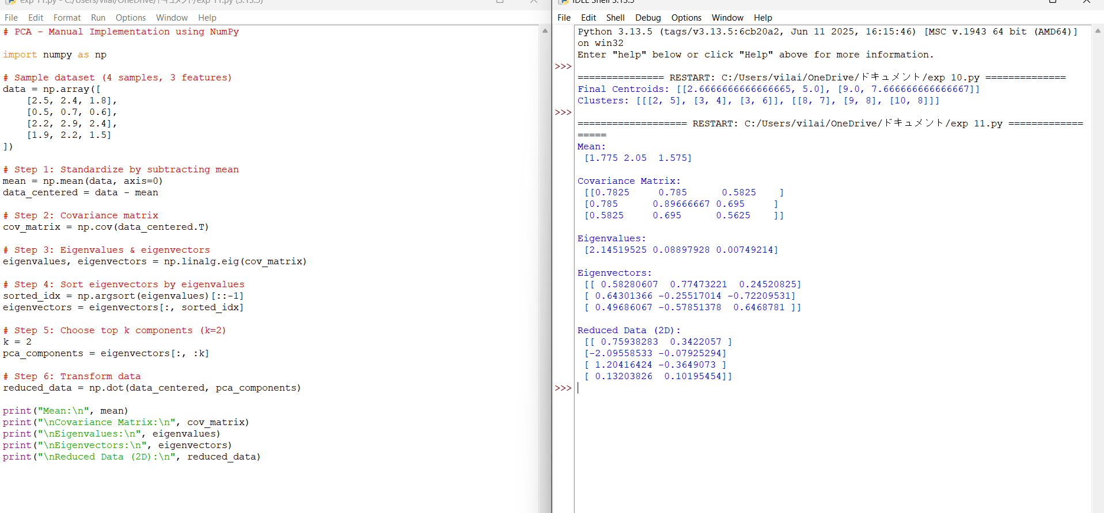
Experiment 12 - Implement Iris Flower Classification using KNN
# Apriori Algorithm - Manual Implementation

from itertools import combinations

# Dataset (Transactions)
dataset = [
['Milk', 'Bread', 'Butter'],
['Milk', 'Bread'],
['Bread', 'Butter'],
['Milk', 'Butter'],
['Bread', 'Eggs'],
['Milk', 'Eggs'],
]

min_support = 0.3 # 30%
min_confidence = 0.6

def get_support(itemset):
count = 0
for transaction in dataset:
if set(itemset).issubset(set(transaction)):
count += 1
return count / len(dataset)

# Step 1: Generate 1-itemsets
items = sorted({item for transaction in dataset for item in transaction})
current_itemsets = [[item] for item in items]

frequent_itemsets = []

while current_itemsets:
next_itemsets = []
for itemset in current_itemsets:
support = get_support(itemset)
if support >= min_support:
frequent_itemsets.append((itemset, support))

# Generate bigger itemsets
for item in items:
if item > itemset[-1]:
new_set = itemset + [item]
next_itemsets.append(new_set)

current_itemsets = next_itemsets

# Generate rules
rules = []
for itemset, support in frequent_itemsets:
if len(itemset) > 1:
for i in range(1, len(itemset)):
for lhs in combinations(itemset, i):
rhs = set(itemset) - set(lhs)
lhs_support = get_support(lhs)
confidence = support / lhs_support
if confidence >= min_confidence:
rules.append((lhs, tuple(rhs), confidence))

print("Frequent Itemsets:")
for itemset, support in frequent_itemsets:
print(itemset, "=> Support:", round(support, 2))

print("\nAssociation Rules:")
for lhs, rhs, confidence in rules:
print(lhs, "=>", rhs, "Confidence:", round(confidence, 2))
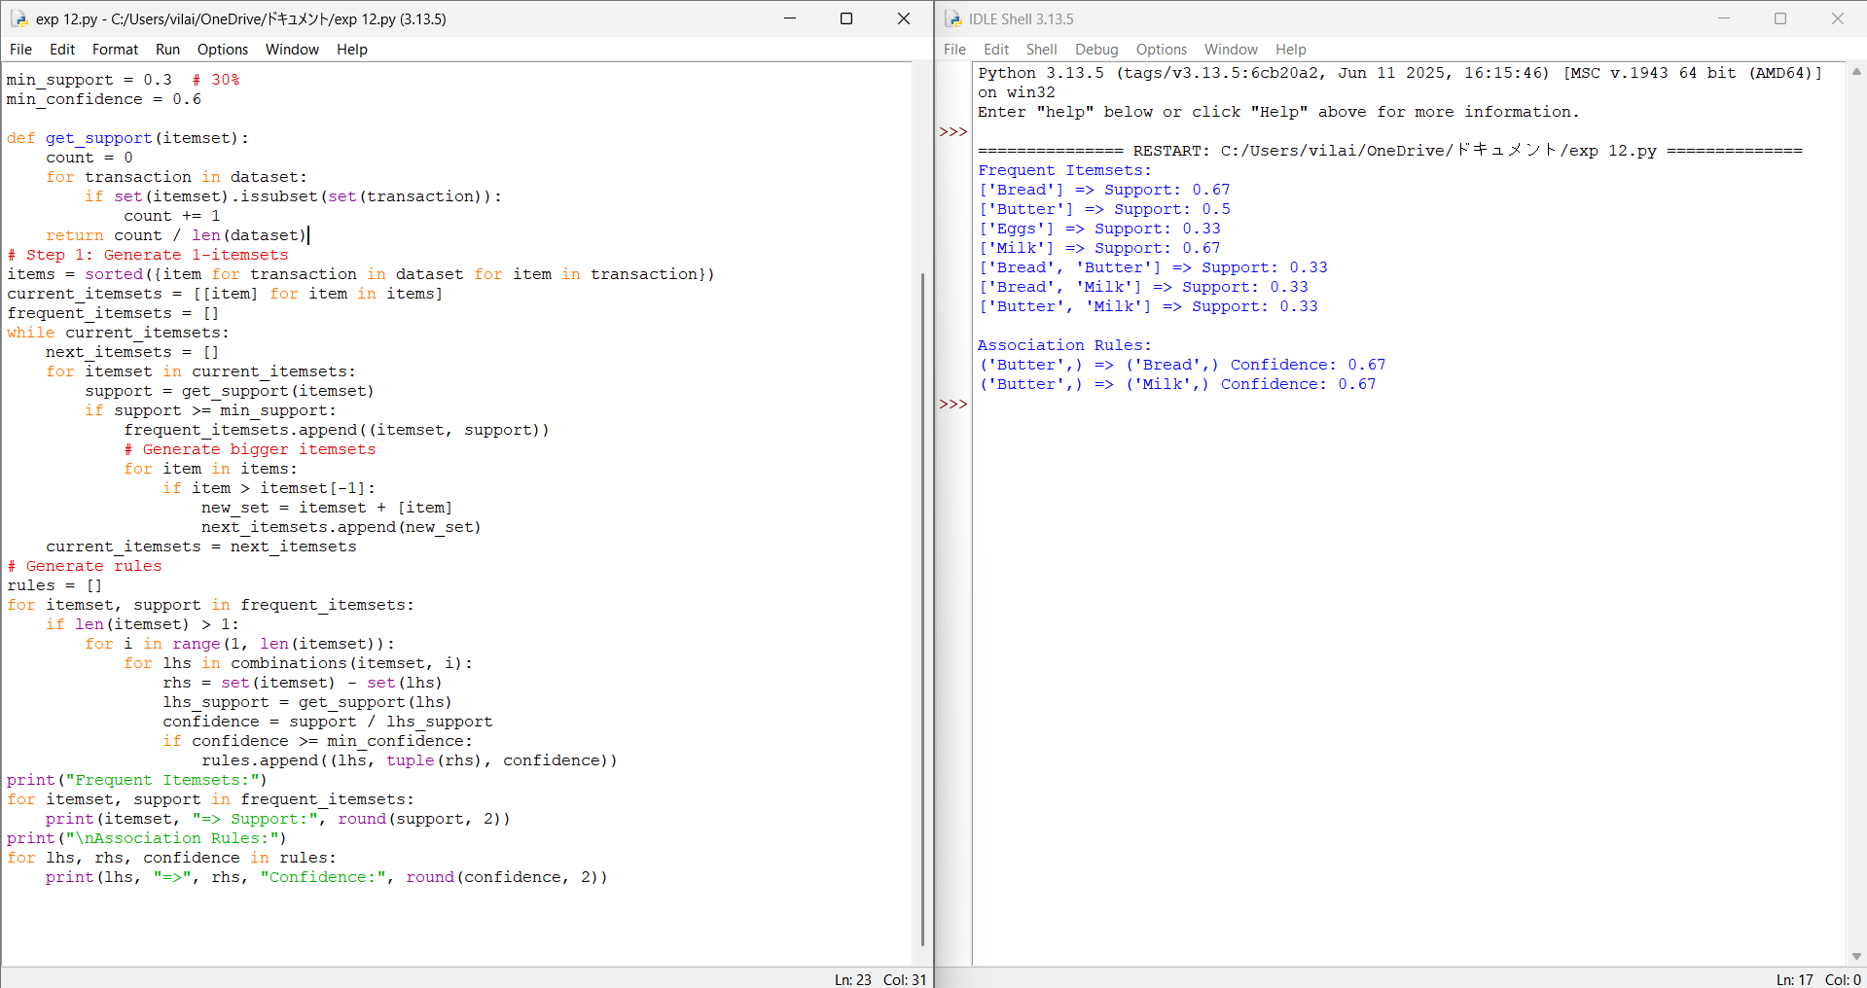
Experiment 13 - Implement the Car Price Prediction Model using Python
# Decision Tree using CART (Gini Index)

from sklearn.tree import DecisionTreeClassifier

# Training data: [features], label
X = [
[2, 4],
[4, 6],
[3, 5],
[9, 10],
[10, 12],
[11, 9]
]

Y = ['A', 'A', 'A', 'B', 'B', 'B']

# Create CART model (uses Gini by default)
model = DecisionTreeClassifier(criterion='gini')

# Train model
model.fit(X, Y)

# Test sample
test_point = [[5, 5]]

# Prediction
prediction = model.predict(test_point)

print("Test Point:", test_point)
print("Predicted Class:", prediction[0])

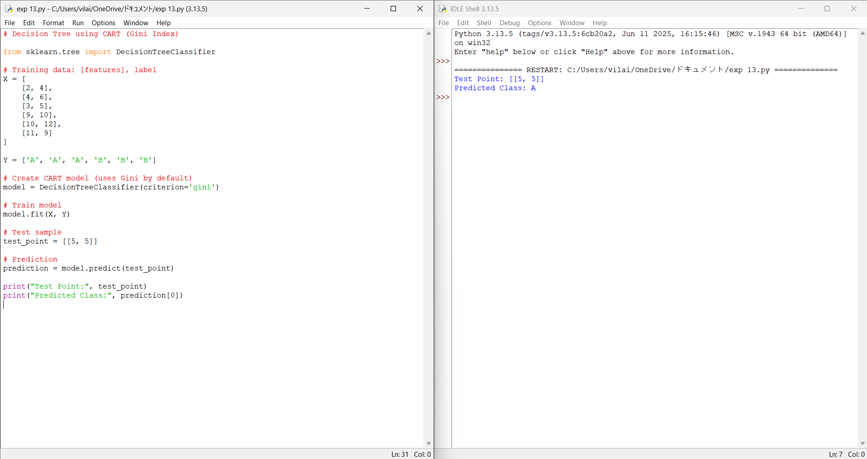

Experiment 14 - Implement House price Prediction using appropriate machine learning algorithm
# Random Forest Classifier

from sklearn.ensemble import RandomForestClassifier

# Training data
X = [
[2, 4],
[4, 6],
[3, 5],
[9, 10],
[10, 12],
[11, 9]
]

Y = ['A', 'A', 'A', 'B', 'B', 'B']

# Create model
model = RandomForestClassifier(n_estimators=5) # 5 trees

# Train
model.fit(X, Y)

# Test sample
test_point = [[5, 5]]

# Predict
prediction = model.predict(test_point)

print("Test Point:", test_point)
print("Predicted Class:", prediction[0])

Experiment 15 -
# Hierarchical Clustering (Agglomerative)

import numpy as np
from sklearn.cluster import AgglomerativeClustering
from scipy.cluster.hierarchy import dendrogram, linkage
import matplotlib.pyplot as plt

# Sample Dataset
X = np.array([
[1, 2],
[2, 3],
[3, 2],
[8, 7],
[9, 8],
[10, 8]
])

# Step 1: Plot Dendrogram
linked = linkage(X, 'ward')

plt.figure(figsize=(7,5))
dendrogram(linked)
plt.title("Dendrogram")
plt.xlabel("Data Points")
plt.ylabel("Distance")
plt.show()

# Step 2: Agglomerative Clustering
model = AgglomerativeClustering(n_clusters=2, linkage='ward')
labels = model.fit_predict(X)

print("Cluster Labels:", labels)

Experiment 15 - Implement Iris Flower Classification using Naive Bayes classifier
# Hierarchical Clustering (Agglomerative)

import numpy as np
from sklearn.cluster import AgglomerativeClustering
from scipy.cluster.hierarchy import dendrogram, linkage
import matplotlib.pyplot as plt

# Sample Dataset
X = np.array([
[1, 2],
[2, 3],
[3, 2],
[8, 7],
[9, 8],
[10, 8]
])

# Step 1: Plot Dendrogram
linked = linkage(X, 'ward')

plt.figure(figsize=(7,5))
dendrogram(linked)
plt.title("Dendrogram")
plt.xlabel("Data Points")
plt.ylabel("Distance")
plt.show()

# Step 2: Agglomerative Clustering
model = AgglomerativeClustering(n_clusters=2, linkage='ward')
labels = model.fit_predict(X)

print("Cluster Labels:", labels)
